# InterSystems IRIS FHIR Server at AWS

You can provision your own InterSystems IRIS FHIR server with couple of clicks.

<https://tinyurl.com/vfw28jj>

That’s a shortened version of:

[https://console.aws.amazon.com/cloudformation/home?region=us-east-1#/stacks/create/template?stackName=InterSystems-FHIR-Server&templateURL=https://isc-tech-validation.s3.amazonaws.com/IRIS-FHIR-Server.yaml](https://console.aws.amazon.com/cloudformation/home?region=us-east-1" \l "/stacks/create/template?stackName=InterSystems-FHIR-Server&templateURL=https://isc-tech-validation.s3.amazonaws.com/IRIS-FHIR-Server.yaml)

(Warning: copy/paste of long version can introduce extra characters. Use shortened version instead.)

All you need is AWS account and at least on EC2 SSH KeyPair.

The link would bring you to the screen like this:

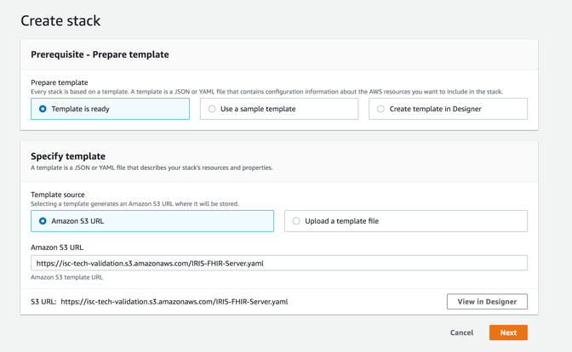 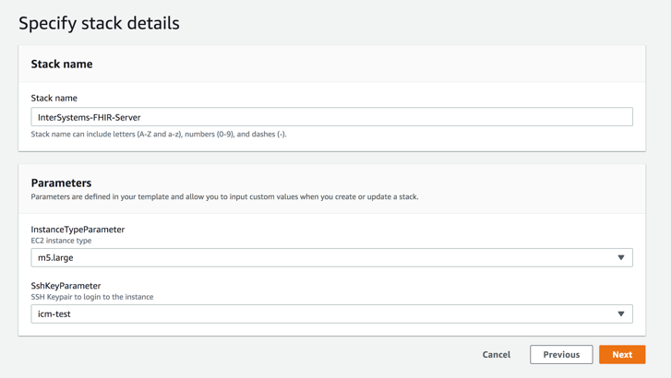

In stack details make sure to enter you existing EC2 SSH Key Pair name. Then accept all the defaults and continue.

In coupe of minutes stack status would change to CREATION COMPLETED and Output section would show few links.

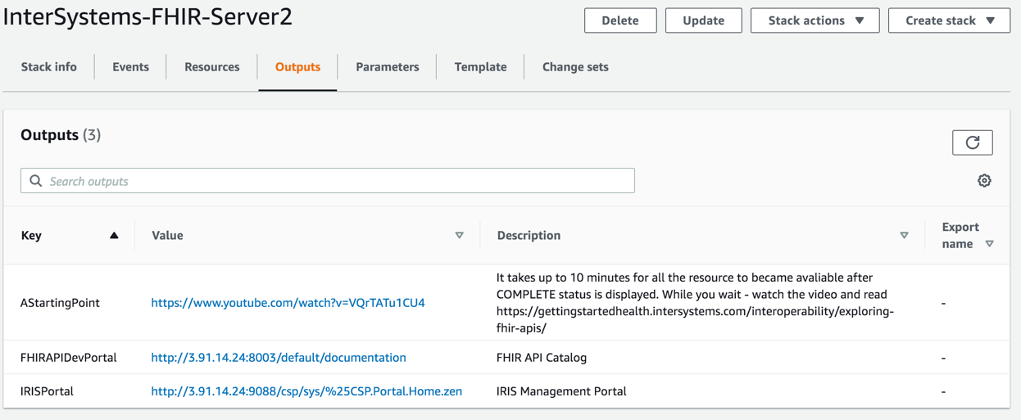

It takes about 10 minutes to all the underlying resources to actually provision, so start by watching the video, explaining what you can do with the FHIR server: <https://www.youtube.com/watch?v=VQrTATu1CU4>

After some time both FHIR API and IRIS portal would be available.

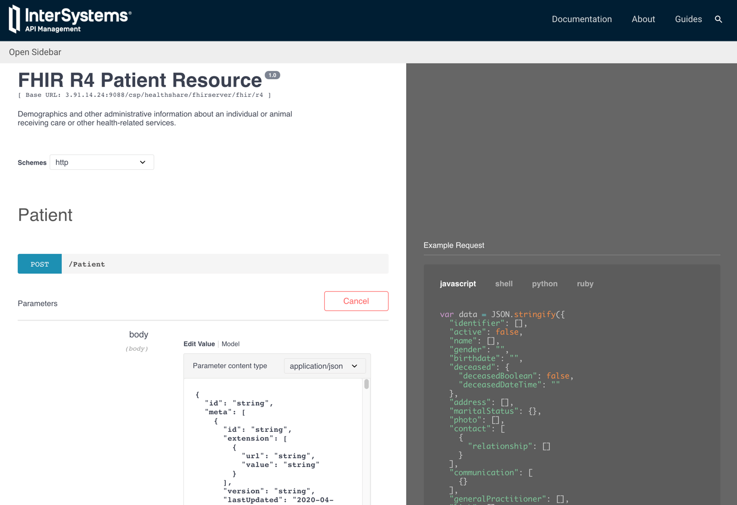

Please reach to us at #tech-fhir and #tech-intersystems channels on slack with any questions.

If you don’t have AWS account or just too busy with finding new ways of fighting COVID-19 – let us know. We can just spin up the server for you and give you the endpoint.

Happy Hacking!!!